Ahsanullah University of Science and Technology

Department of Computer Science and Engineering

CSE 2210: Digital Electronics and Pulse Techniques Sessional

## **Section: B2**

## **Experiment Time: 20 Minutes Submission Time: 10 mins**

## **Submission End Time: 4:10 PM**

## **Experiment # 3**

**Name of the experiment: Study of a TTL NAND gate with totem-pole output.**

**Circuit Diagram:**

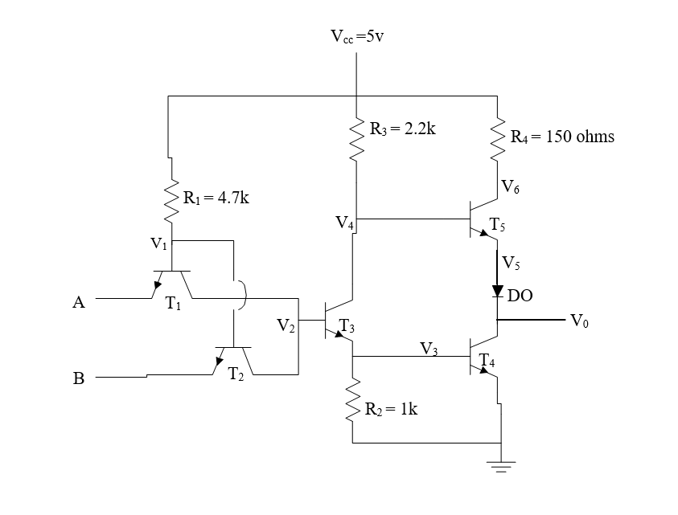

**Procedure:**

1. Measure the *V*0, *V*1, *V*2, *V*3, *V*4, *V*5 & *V*6 for all possible input combinations.
2. Calculate noise margins. (Write in report only)

**Questions:**

1. Analyze the operation of TTL NAND gate with the experimental data.
2. What are the differences of transistors T1 & T2 with that of a multi-emitter transistor? [Hint: Millman Sec 4-7,5-11]
3. What is totem-pole stage? Why it is used in place of passive pull-up resistor? [Hint: Millman Sec 5-12]
4. What is the function of T3? [Hint: Millman Sec 5-12]
5. Why resistor R4 is used? [Hint: Millman Sec 5-12]
6. Why diode D0 is used in the circuit? Can it be placed elsewhere? [Hint: Millman Sec 5-12]
7. Why two totem pole gates cannot be wire ANDed? [Hint: Millman pg. 151]
8. What are the features and advantages of TTL gates? [Hint: Millman Sec 5-15]

**Report:**

1. Objective.
2. Circuit diagram.
3. Answer to the questions.
4. Experimental data.
5. Calculations.
6. Discuss the findings.

**This is a theoretical explanation. Your NM(0) and NM(1) will change according to the measurement you have taken. Do not copy-paste these values directly to your lab report.**

**NM(0):**

Negative Spike:

For all inputs high, the output should be low. So, a negative spike will change the output to high. For the given circuit, if T3 and T4 will have to stop conducting to change the output to high.

We consider the case of the negative spike. We know that a diode will start conducting at 0.6 volts. emitter-base junction of T1 and T2 can be considered as a diode. So it will start conducting when it gets at least 0.6 volts.

When all input 1, Suppose V2 + V3 = 1.44+0.728 = 2.168 V. So, NM(0) = - (5-2.168) = -2.832V

**NM(1):**

Positive Spike:

If only one input is at V(1), and the other is at V(0), then if V(0) tends to increase we need only 0.5+0.5 = 1.0 volt at T3’s base to make the path along T3 -T4 to conduct. Suppose, V2 = 0.025V

NM(1) = 1 – 0.025 = 0.975 V